EXPERIMENT NO. 1
GENERATION AND CLASSIFICATION OF CONTINUOUS-TIME AND DISCRETE-TIME SIGNALS
OBJECTIVE:
(i) To generate and visualize basic continuous-time signals such as unit step, unit impulse,ramp, sinusoidal, and exponential signals.
(ii) To generate and visualize basic discrete-time signals and analyze their amplitude and time-index characteristics.

MATLAB CODING :
% Experiment 1: Generation of Continuous-Time Signals
clc; clear; close all;
t = -1:0.001:1;
A = 2; f0 = 5; a = 1;
imp = double(abs(t)<0.0005);
step = double(t>=0);
ramp = t.*step;
expSig = exp(-a*t).*step;
sinSig = A*sin(2*pi*f0*t);
figure;
subplot(3,2,1); plot(t,imp); grid on; title('Unit Impulse'); xlabel('t'); ylabel('Amplitude');
subplot(3,2,2); plot(t,step); grid on; title('Unit Step'); xlabel('t'); ylabel('Amplitude');
subplot(3,2,3); plot(t,ramp); grid on; title('Ramp'); xlabel('t'); ylabel('Amplitude');
subplot(3,2,4); plot(t,expSig); grid on; title('Exponential'); xlabel('t'); ylabel('Amplitude');
subplot(3,2,5); plot(t,sinSig); grid on; title('Sinusoidal'); xlabel('t'); ylabel('Amplitude');

MATLAB CODING :
% Experiment 2: Generation of Discrete-Time Signals
clc; clear; close all;
n = -20:20;
A = 2; f0 = 0.1; a = 0.1;
imp = double(n==0);
step = double(n>=0);
ramp = n.*step;
expSig = (0.8).^n .* step;
sinSig = A*sin(2*pi*f0*n);
figure;
subplot(3,2,1); stem(n,imp,'filled'); grid on; title('Unit Impulse');
subplot(3,2,2); stem(n,step,'filled'); grid on; title('Unit Step');
subplot(3,2,3); stem(n,ramp,'filled'); grid on; title('Ramp');
subplot(3,2,4); stem(n,expSig,'filled'); grid on; title('Exponential');
subplot(3,2,5); stem(n,sinSig,'filled'); grid on; title('Discrete Sinusoid');
xlabel('n');

OUTPUT :
To generate and visualize basic continuous-time signals such as unit step, unit impulse,ramp, sinusoidal, and exponential signals.
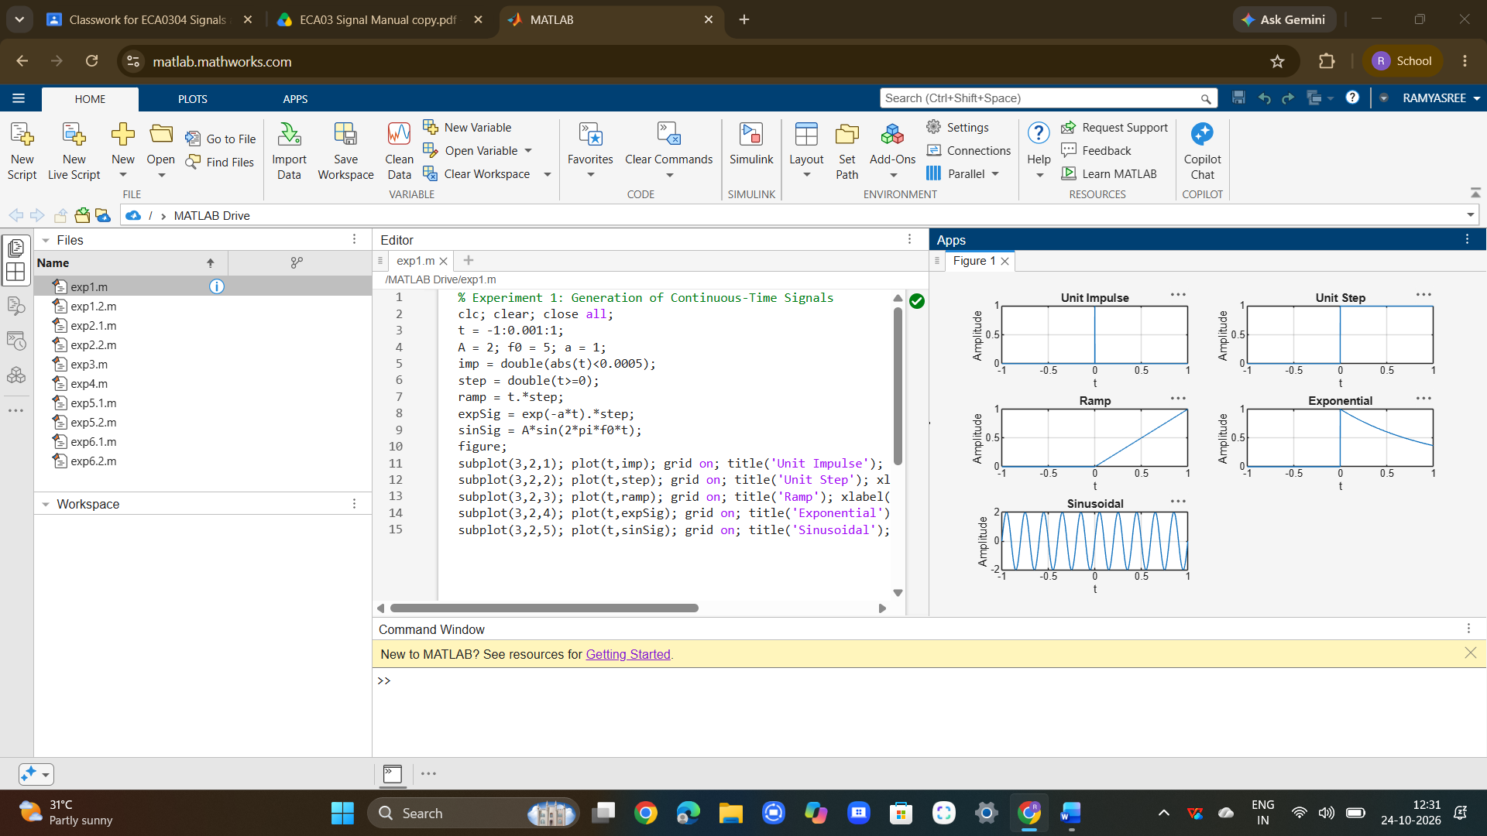
To generate and visualize basic discrete-time signals and analyze their amplitude and time-index characteristics.
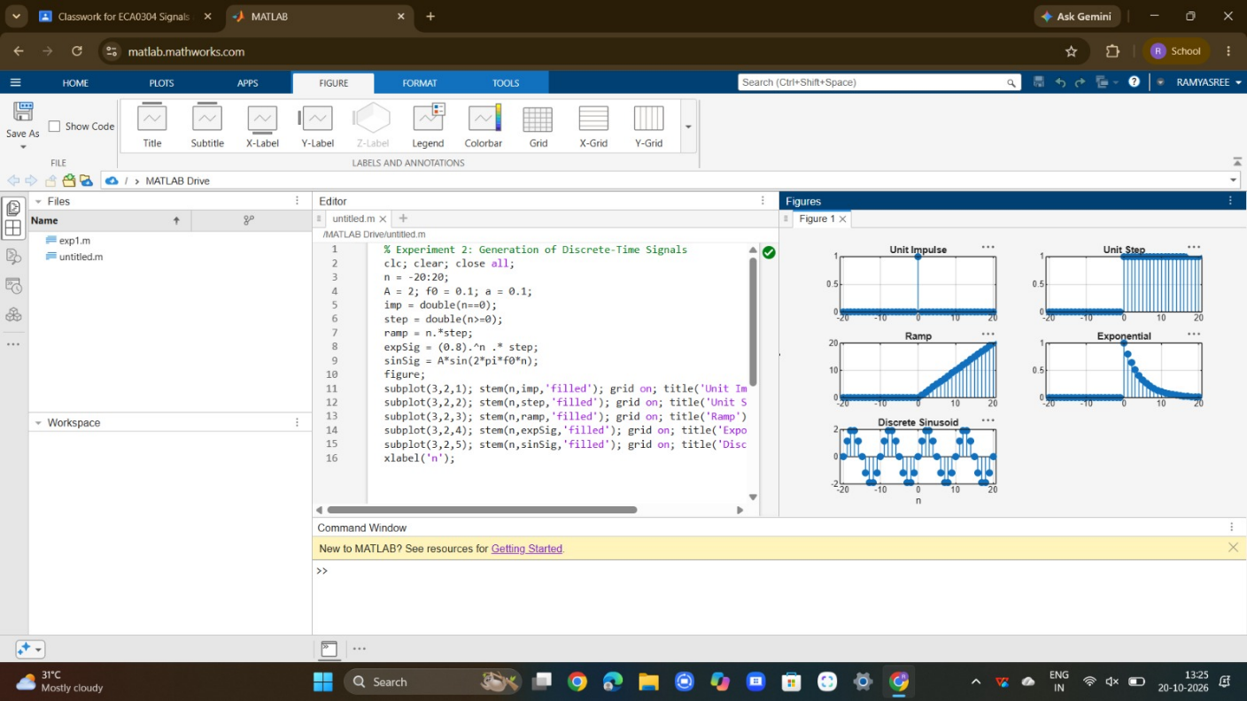

CONCLUSION:
The continuous-time and discrete-time signals were generated and analyzed successfully. The signals were classified as periodic or aperiodic, and the even and odd components were obtained and used to reconstruct the original signal successfully.

